Readme File - Project QSC

Below are the parameters configured for this job
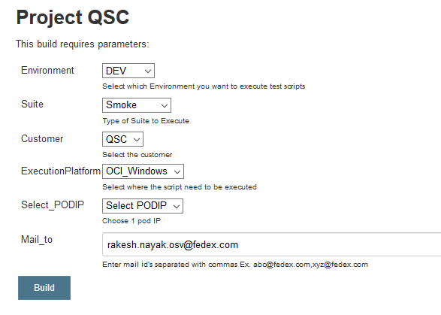

- Environment- This dropdown allows you to select the environment where you want to run the scripts. User can select any 1 environment from the below list (DEV, TEST, STAGE)
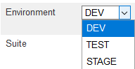

- Suite- - This dropdown allows you to select the suite for which you want to run the scripts. User can select any 1 suite from the below list (Smoke, Sanity, Regression)

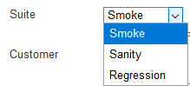

- Customer- This dropdown allows you to select the customer for which you want to run the scripts. User can select any 1 customer from the drop down
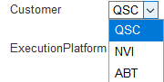

- Execution Platform- This dropdown allows you to select the platform where you want to run the scripts. User can select either OCI Windows chrome or OCI POD form the dropdown.
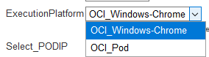

- Select PODIP- This dropdown allows you to select the POD ID where you want to run the scripts. This dropdown is only applicable if user has selected OCI POD in execution platform above.

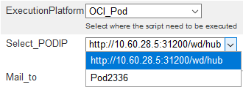

- Mail_to- This text box allows user to input their Email address. Whenever the job will be executed completely, a HTML report will be sent to the given Email address.

